- Parent Centers:
  - http://www.parentcenterhub.org/find-your-center/
- Section 504 and the Education of Children with Disabilities:
  - https://www2.ed.gov/about/offices/list/ocr/504faq.html
  - www.ADATA.org

- Individuals with Disabilities Act Info:
  - http://www.parentcenterhub.org/idea/
  - www.ADATA.org
- National ADA Network:
  - 800-949-4232, www.adata.org
- Job Accommodation Network:
  - www.askjan.org
- Equal Employment Opportunity Commission:
  - www.eeoc
- U.S. Dept. of Justice:
  - 800-514-0301, www.ada.gov

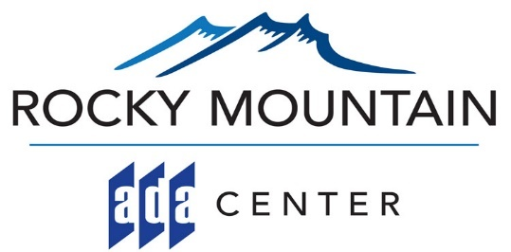
800-949-4232 (V, TTY)
719-358-2460 (VP)
www.rockymountainada.org
Technical Assistance / ADA Information
Referral & Networking with other Disability Organizations
Research
Training
Material Dissemination

Stay in Touch!
* Monthly Enewsletter Sign Up: http://RockyMountainADA.org
* Facebook: www.facebook.com/RMADACenter
* Twitter: Twitter@RockyMtnADA
* Check out our “Sign of the Day” on Instagram!
https://www.instagram.com/rockymountaindailysigns/

The Rocky Mountain ADA Center is Operated by
Meeting the Challenge, Inc.

- Generates customized implementation services
- Offers guidance on various disability rights laws
