Who Are Collaborative Partners In My State  - ______________________________  - ______________________________  - ______________________________  - ______________________________  - ______________________________ | 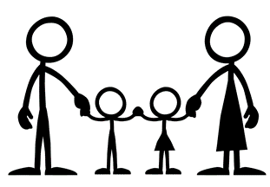
WHAT ARE THE GIFTS, ASSETS, TALENTS, RESOURCES WE ALREADY HAVE PRESENT WITHIN OUR COMMUNITY?  ____________________________________  _____________________________________  HOW MIGHT WE ORGANIZE? LINK TOGETHER? CREATE INITIATIVES?  ____________________________________  ____________________________________  ____________________________________ | WHAT ARE THE FIRST STEPS?  - WITHIN THE NEXT 2 WEEKS  - WITHIN THE NEXT 3 TO 6 MONTHS  - WITHIN THE NEXT YEAR

